**Individual Assignment 3: Recommendations for Netflix's "next Big Thing"**

Netflix is looking at what can be their next “Big Thing” on the platform. Data was collected from IMDB, Facebook Analytics, Google Trends and Tweetology to understand the audience’s response to entertainment released over the years 2018-2022.

At first the IMDB data was looked at to see what was the most popular movies, tv shows and genres based on a calculated QScore (average ratings x number of votes).

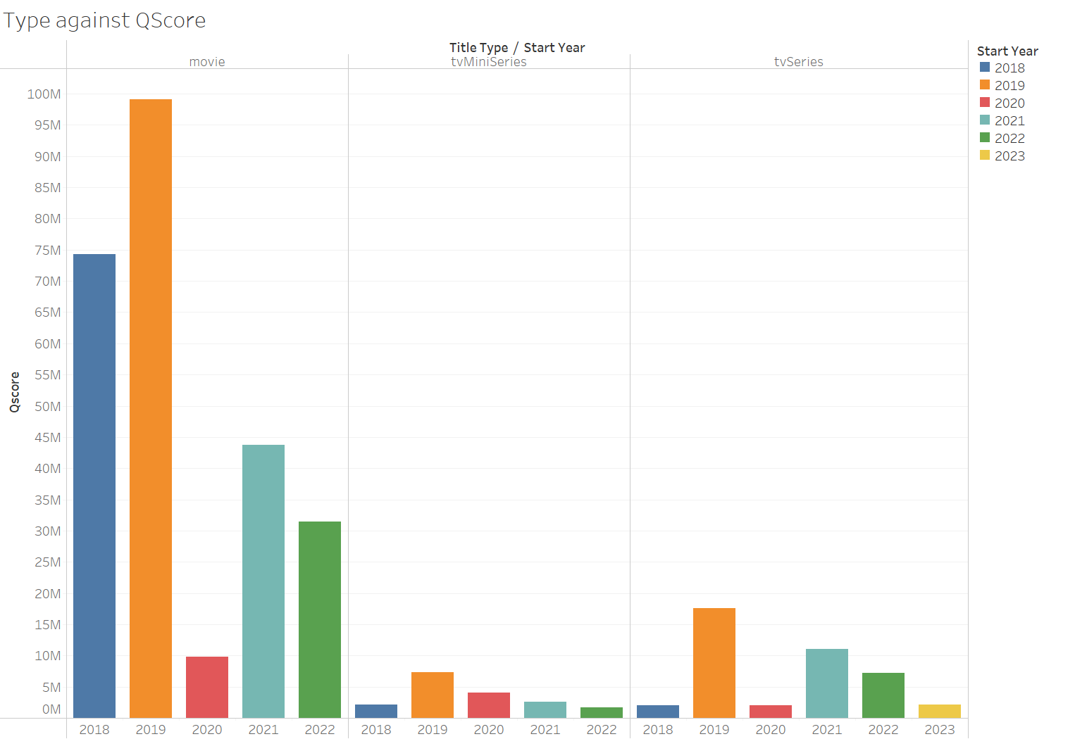

A look at the top 100 Qscores across various entertainment types and the years shows that movies followed by TV series are having the highest scores with a the highest total in 2019. Based on the above and since this is Netflix, a platform for movies and TV shows, the focus of this report will be on the same.

Continuing on this track, the year 2020 was the lowest performing time for these formats. The reason for this might be because it was the year that COVID broke out and people were more worried about that as can be seen from Google Trends which shows a dip in in the interest for movies when COVID was increasing. The below graph also shows that the number of titles released during 2020 was much lesser than all the other years.

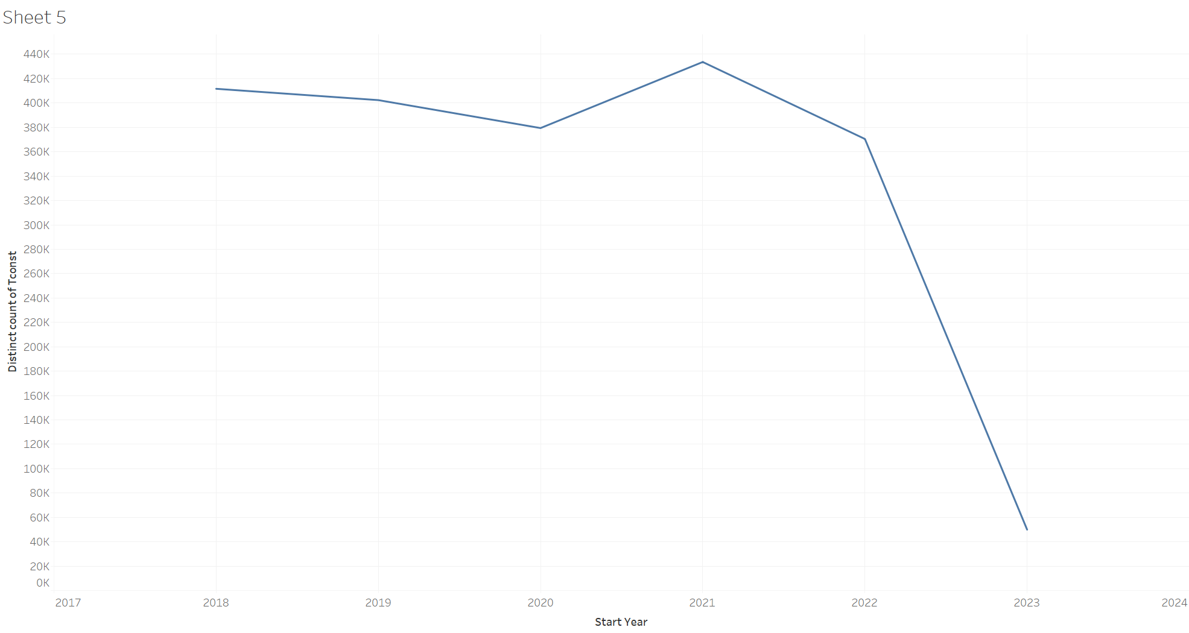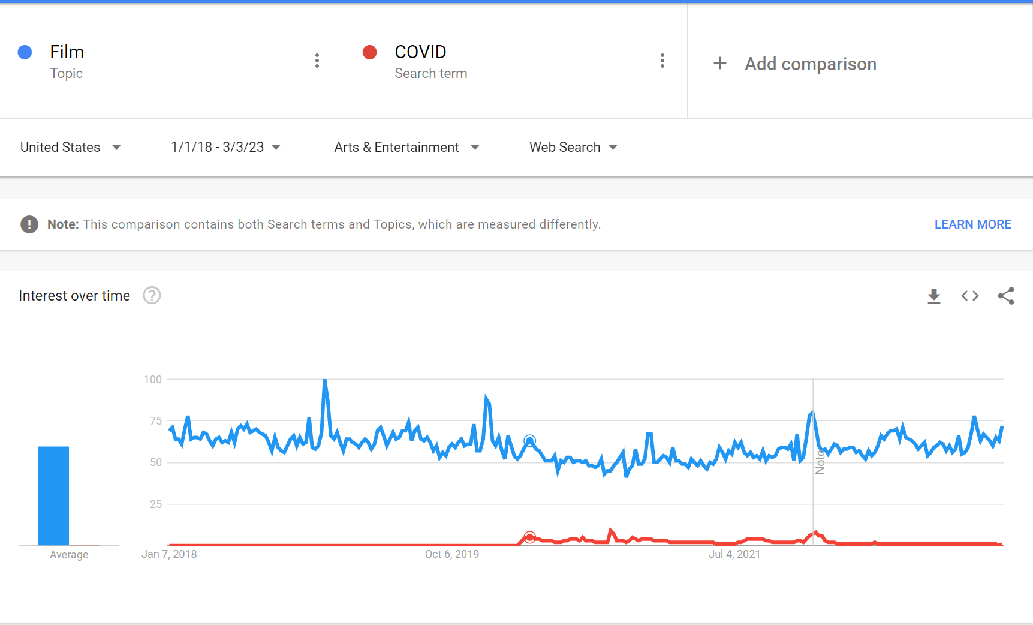

COVID was a big change in many people’s lives and changed many people’s consumption habits especially in terms of entertainment.

One of the biggest changes being an increase in consumption of TV shows compared to movies.

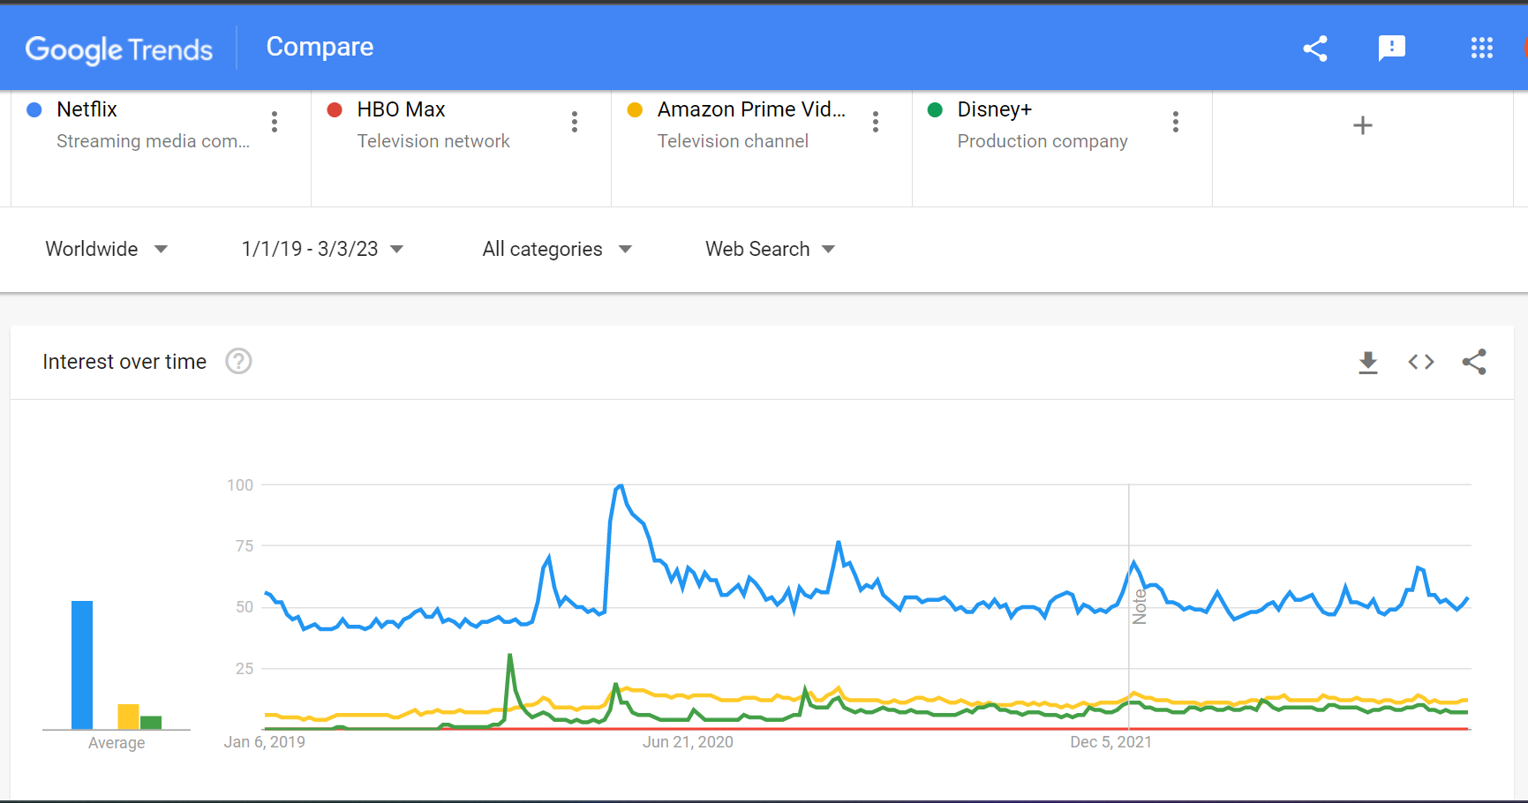

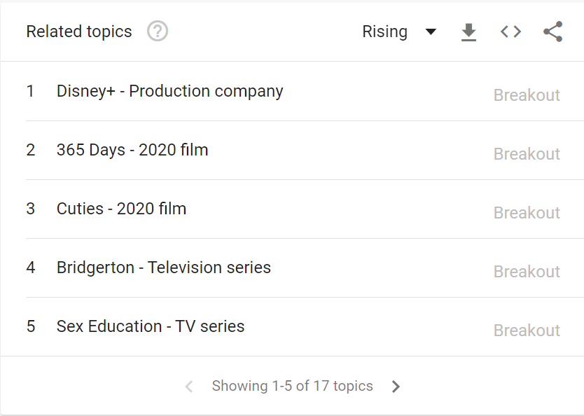

This was then compared to the data from Google Trends to see what the audience was searching for and did they coincide with the popularity according to IMDB.